**\*Please make a copy of this document and include this in your GitHub repository for your submission, using the tag #AndroidDevChallenge\***

**Tell us what your idea is.**

A lot of users undergo mental stress and depression, and there are less number of ways currently that someone notices another person for those traits. Many patients go unnoticed, leading to a more severe state, where he/she becomes untreatable. With the rise in the usage of mobiles, most of the people tend to search or use words according to their mood. This could help us a lot in detecting user’s mental state.

I am aiming to develop an Android application that detects user’s mental health based on their search and word choices. The application would analyse the user word choices with the help of on-device Machine Learning to calculate the results. A record of what user’s search relates to (being depressed or not depressed) will be saved on the device, and an active graphical analysis could be viewed for it.

Every user will be asked to add up some related/close contacts, which could be gamified so that users add authentic contacts as close ones, rather than adding fake/irrelevant accounts. In case the Machine Learning algorithm detect the user to be in a negative state, the user won’t be directly notified, instead the chosen contacts would be alarmed about the incident so that they could take necessary action as required.

The application might seem to be of less use if used as a separate application, but if integrated along with GBoard, which is used by a large majority of Android OS user’s, this could seem to be a potentially good solution to control mental health.

**Tell us how you plan on bringing it to life.**

I’ll be using Tensorflow (and Keras if necessary) to build the Machine Learning Model and further TensorFlow Lite to extend the algorithm to be on-device, onto the Android application.

The first step in building this project would be to build a better Machine Learning model with a higher accuracy rate, followed by the development of the Android app, and eventually their integration using TensorFlow Lite.

I previously have built a prototype of the application, which would be made again from scratch, because it would have a considerable amount of changes.

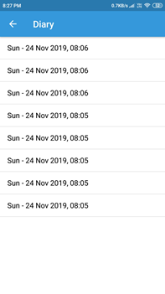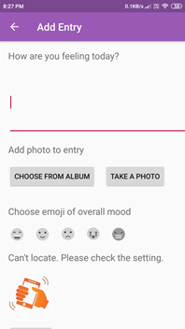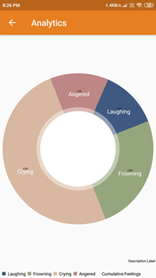

*A track of what user entered A user could manually enter his/her mood Analytics*

Although the application I built required the user to explicitly open the application and enter his mood for the day, this could be faked by the user, leading to false negatives. That is why it is important to track what words the user actually uses across the day, and then continuing the analysis.

I would need help from the Google team at a couple of points over here.

* Since depression is not a thing that could be detected by a few number of searches, we would have to use another algorithm for that. It would require several hours of brainstorming for an individual like me. But with the help of Google experts, it could be found potentially fast.
* Moreover, ways on how to get actual user data, rather than the application I created wherein the user manually entered the data, will also be an area of guidance for me.

The timeline on how the application could be built could vary a lot because of my University examinations or so in the month of March, but the application could be surely completed by 1st May, 2020.

The creation/development of the Machine Learning algorithm would take around a month and constant hyperparameter tuning for the following time period. The development of the Android app would span along a time of 2 weeks. With the remaining time to figure out the two main areas of focus, which would possibly need help from Google.

**Tell us about you.**

I am Tavish Jain, pursuing my undergraduate degree from Delhi Technological University (formerly Delhi College of Engineering) majoring in Software Engineering. I am an Android developer and a Machine Learning Researcher, aiming to become better at Software Development. I've also completed the Associate Android Developer exam by Google.

I am also innovating a Software Bug Predictor at my university as a Research Assistant which involves analysis of the data, software design, software development, software testing, maintenance and delivering a finalised working software as a product, that could possibly be released publicly, aiming to increase the development speed by 40%.

I am also innovating a Software Bug Predictor at my university, involving machine learning, data analysis, data mining, software design, development, testing, maintenance, hosting on Cloud and delivering a cross-platform application. Conducting research work and applying various Machine Learning Algorithms, programming skills, troubleshooting technical problems, testing on multiple test cases would be the main area of interest. The project aims to reduce the development time by 40% as a lot of time is spent in Software Debugging.

**Next steps.**

* Be sure to include this cover letter in your GitHub repository
* Your GitHub repository should be tagged #AndroidDevChallenge
* Don’t forget to include other items in your GitHub repository to help us evaluate your submission; you can include prior projects you've worked on, sample code you've already built for this project, or anything else you think could be helpful in evaluating your concept and your ability to build it
* [**The final step is to fill out this form to officially submit your proposal.**](https://docs.google.com/forms/d/e/1FAIpQLSe43koQL33IzgxXQl29Ex3AhFuqd4hQzxLiXREqwRkDGtx1vA/viewform?usp=sf_link)